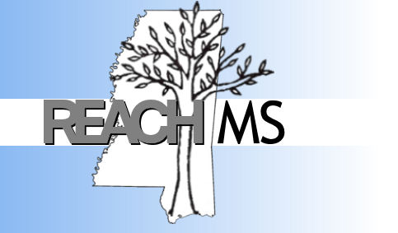
REACH MS
Mississippi’s State Personnel Development Grant

University of Southern Mississippi Phone: 601.266.4693
118 College Drive # 5057 Fax: 601.266.4693
Hattiesburg, MS 39406 Email: REACHMS@usm.edu

Realizing Excellence for All Children

Positive Behavioral Interventions and Support
Product Book

Description of Section | In Place | Needs  Improvement | Not in Place
Description of PBIS
Mission Statement
PBIS Team Members Roles and Responsibilities
Agendas, Minutes, Sign-In
Referral Process (flowchart)
Definitions of Problem Behaviors
Referral Form (major & minor)
Expectations and Rules
Lesson Plans
Description of Reinforcement System (students & faculty)
Interventions/Consequences for Rule Violations (major & minor)
Data

Any items related to implementation of PBIS such as pictures, videos, professional development activities etc…

