Big List of Rules
Bathroom

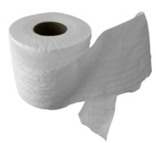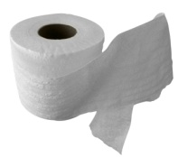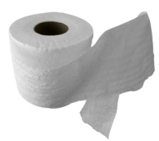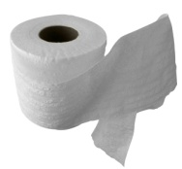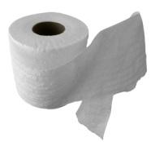

Keep it neat | Throw trash in container
Keep it clean | Have bathroom pass
Knock before entering | Turn off sink faucet
Wash hand with soap | Quiet voices
“Aim” to please | 5 students in bathroom at a time
Return to class quickly & quietly | Give each person privacy
Keep hands, feet & objects to self | Use restroom in a timely manner
Use fixtures appropriately | Use 2 squirts of soap and 3 paper towels
Keep it neat | Wait patiently for your turn
Keep it clean | Use 2 and 2 (2 squirts soap and 2 paper towels)
Knock before entering | Throw trash in container
Wash hand with soap | Have bathroom pass
“Aim” to please | Turn off sink faucet
Return to class quickly & quietly | Quiet voices
Keep hands, feet & objects to self | Throw away trash
Use fixtures appropriately | Return to class promptly
Tell teacher if another student needs help | Accept consequences without arguing
One student to a stall | Privacy for all
Flush Toilet | Keep water in the sink
Practice appropriate personal hygiene | Enter and exit quickly
Discard garbage in designated areas | Leave no trace
Stay in own area | 5 students in bathroom at a time
Pick up after self | Throw away trash
Use bathroom during transitional break times | Return to class promptly
Report problems to adult/staff | Accept consequences without arguing
Use bathroom in a timely manner | Privacy for all
Report problems to adult/staff | Keep water in the sink
Use bathroom in a timely manner | Enter and exit quickly
Bring only necessary materials | Leave no trace
Be polite | 5 students in bathroom at a time
Be quick and quiet | Throw away trash

Big List of Rules
Classroom

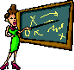

Use good manners | Use polite and kind words
Raise hand before talking | Accept consequences without arguing
Listen quietly when others are speaking | Bring conflicts to teacher’s attention
Keep your area clean | Wait your turn
Walk quickly & quietly when transitioning | Give your best effort on assignments
Follow directions 1st time given | Unpack and be in your desk before announcements
Complete all assignments on time | Begin board work immediately
Participate in discussions/activities | Use polite and kind words
Stay seated | Use good manners
Hand, feet & objects to self | Have all necessary materials
Keep all furniture legs on the floor | Keep discussions to classroom topic
Be on time | Use appropriate language, tone and gestures
Attend class daily | Clean up after self

Big List of Rules
Break

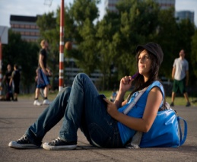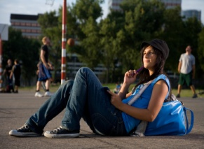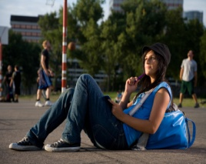

Report immediately to break area | Keep hands, feet and objects to self
Gather your materials before leaving break | Throw away trash in designated container
Line up to enter building after break | Stay in designated area
Use appropriate language, tone and gestures | Take care of all business before leaving for break
Enter building quietly | Use appropriate language, tone and actions

Big List of Rules
Bus
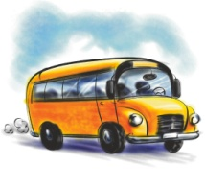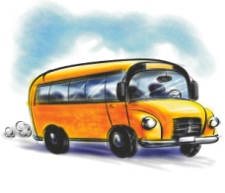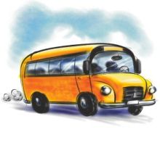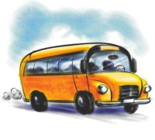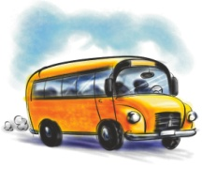
Stay seated | Leave all items in your backpack
Listen to driver | Say seated while bus is moving
Keep hands, feet and objects to self | Clean up after self
Use kind words/actions | Notify bus driver of problems
Use appropriate language, tone and gestures | Walk to seat
Wait your turn to enter and exit | Remain seated
Keep food in your backpack | Keep hands and feet in your own space
Keep large items in your lap while seated | Enter and exit quietly and orderly
Maintain personal space | Keep bus clean
Stay seated facing forward | Follow directions 1st time given
Be on time | Keep aisle clear
Use quiet voices | Get off only at your stop

Big List of Rules
Playground
Use equipment properly | Share and help others
Use equipment the was designed | Pick up litter
If you break something, let a teacher  know | Return equipment to proper place
Take turns | Accept consequences without arguing
Stay in sight of your teachers | Stop playing when whistle blows
Hand, feet and objects to self | Line up calmly and quickly in correct line
Leave what is on the ground on the ground | Stay in your place in line
Report any harmful situation to teacher | Bring/wear jacket during cold weather
Include others | Rocks and sticks stay on the ground
Use kind words and actions | Use appropriate language, tone and  gestures
Choose game or activity with school equipment | Dress for the weather
Follow instructions 1st time given | Listen for whistle, stop, line up
Big List of Rules
Assemblies

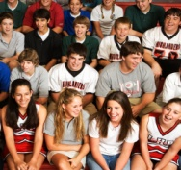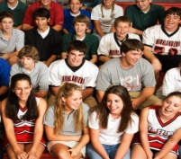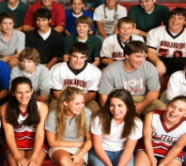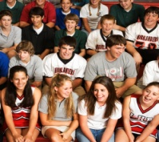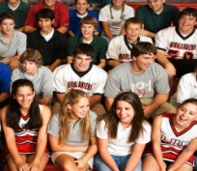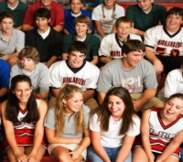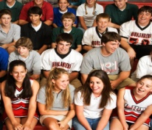

Keep hand, feet and objects to self | Stay seated on your bottom
Wait for directions for arrival and dismissal | Stay with your group
Enter and Exit calmly and quietly | Enter/Exit quickly and quietly
Sit flat on floor | Keep eyes forward
Pay attention to presenter | Listen quietly
Silence when presenter is talking | Bring what you need before leaving class
Be seated, stay seated | Be on time
Go to Assigned area | Applaud appropriately
Follow adult directions | Bring only necessary items
Sit facing forward on bottoms with legs crossed | Look and listen for instructions

Big List of Rules
Dismissal
Take care of all transportations changes before the end of the day | Keep hands, feet and objects to self
Pay attention for your ride | Bring note from parents is changing transportation
Wait for bus or car to stop completely before stepping off sidewalk | Promptly walk to after school car, bus or car pickup area
Stay left on the grass | Sit quietly while waiting for your ride
Leave classroom at the appropriate time | Hold handrails
Leave in a calm, orderly manner | Keep hands, feet and objects to self
Help others | Follow all adult instructions
Move quickly | Listen for announcement
Observe “Quiet Zone” | Walk with your teacher to the exit/bus
Use a whisper voice | Leave all items in your backpack

Big List of Rules
Cafeteria

Use inside or quiet voices | Take only what you can eat/drink
Use utensils for eating | Walk quietly to your table
Hand, feet and objects to self | Clean up messes
Throw away trash | Raise hand if you need something
Eat only your food | Say your lunch number clearly
Be ready to leave at end of lunch | Keep your space clean
Eat in a timely manner | Keep food on tray or in mouth
Waiter your turn in line | Return trays to appropriate location
Move away from conflicts or distractions | Use quiet voices
Ask for help if needed | Keep food and drinks in cafeteria
Use appropriate language, tone and gestures | Clean up your table
Keep your place in line | Go directly to cafeteria
Use good manners | Bring appropriate money or bagged lunch
Pay for all food | Get all utensils and food before sitting down
Stay in assigned seat/area | Sit 8 to a table
Stay in seat until dismissed | Silence during announcements and dismissal
Accept consequences without arguing | Take direct route to the cafeteria
Leave your seat only with permission | Move through line quickly
Enter and exit quickly and quietly | Say “please” and “thank you”
Walk | Walk carefully carrying tray with both hands
Listen to monitors | Stay seated facing table with feet on floor
Remain in lunch line until you are served | Allow anyone to sit next to you
Be prepared to leave at appropriate time | Empty tray when leaving cafeteria

Big List of Rules
Hallway

Walk to the right | Move quietly at a walking pace
Hands, feet and objects to self | Be friendly to others
Use quiet voices | Walk at all times
Stay in line | Use appropriate language, tone and gestures
Go directly to your destination | All cell phones off and in lockers until after school
Walk one stair at a time | Give assistance when needed
Leave together | Keep hallways clean and uncluttered
Stay together | Report dangerous situations/bullying to an adult
Use low voices during class times | Have all materials you need for your next class
Keep lockers locked | Have pass visible
Focus on your own business | Use locker at scheduled times
Move to class quickly and quietly | Use indoor voice
Carry a pass | Use polite/kind words
Take the most direct route to class | Walk with space between you and other people
Accept consequences without arguing | Walk directly to next class
Travel without talking | Be in assigned area when bell rings
Pick up trash | Use assigned locker
Avoid being a distraction to other classrooms | Stay in straight line
Walk facing forward | Observe “Quiet Zone”
Tie shoes before entering hallway | Public display of affection prohibited

