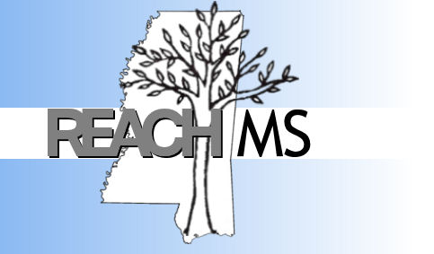
REACH MS
Mississippi’s State Personnel Development Grant
University of Southern Mississippi Phone: 601.266.4693
118 College Drive #5057 Fax: 601-266-4691
Hattiesburg, MS 39406 Email: REACHMS@usm.edu

Realizing Excellence for ALL Children in Mississippi

School – wide Positive Behavior Interventions and Supports
Training Readiness Checklist

School: ________________________________________________ District: ________________________________________________ Date: _________

Person Submitting Checklist: ________________________________________________ Email: ________________________________________________
Directions: Each participating school is required to complete several items prior to receiving SWPBIS training. Completion of this checklist (within the time-frame) ensures more positive outcomes and allows your school to participate in upcoming PBIS trainings sponsored by REACH MS.
Requirement | Completed? |  | Action
1. View REACH MS’s Positive Behavior Interventions and Supports in  Mississippi DVD. Available at www.usm.edu/reachms, or by  contacting us at 601 – 266 – 4693. | - Yes | - No | Presenter: ___________________________________  Date: _______________________________________
2. Majority of faculty, staff and administrators are interested in  implementing School – wide PBIS. | - Yes | - No | Number or Percent in Favor: ____________________  Number or Percent Opposed: ___________________  Number or Percent Undecided: __________________
3. A Positive Behavior Interventions and Supports Team is formed  and has broad representation. (i.e. general education teachers, special  education teachers, school administrators, counselors, family  members, bus drivers school support workers, counselors, behavioral  specialist and students.) | - Yes | - No
4. The school has identified at least two family members, one of a child  receiving special education services and one of a child receiving  general education services, to participate on PBIS team. | - Yes | - No | Family Members Names  - ____________________________________  - ____________________________________
5. SWPBIS Team commits to meeting at least monthly to analyze and  problem solve school – wide data and to continue to build faculty  consensus through ongoing training and PBIS updates. | - Yes | - No | Location: ____________________________________  Date/Day: __________________________________  Time: _______________________________________
6. Principal or assistant principal who is responsible for making  decisions is an active participant on the PBIS team and agrees to  attend all PBIS trainings. | - Yes | - No | List of Participating Administrators
7. Principal commits to School – wide PBIS is aware that SWPBIS is a  3 – 5 year process that will require ongoing training and/or  revisions of the school’s PBIS plan. | - Yes | - No | Marking yes, indicates that the principal has agreed to  this commitment.
8. PBIS Team has reached a consensus and completed the SWPBIS  Initial Benchmarks of Quality. | - Yes | - No | Complete Benchmarks of Quality and attach.
9. School has allocated/secured funding from their district to  support their school-wide initiatives. Examples of funding sources  include SIG funds, district support, community fundraisers, PTO,  etc… | - Yes | - No | Source(s):
10. A school improvement plan exists that includes school – wide  discipline (i.e., behavior, school safety, school climate) as one of  the top school goals. | - Yes | - No | Marking yes, indicates that the principal has agreed to this commitment.
11. REACH MS has permission to utilize product samples for  future trainings, technical assistance activities, professional  conference presentations, or submission to scholarly publications  and may request occasional site visits. | - Yes | - No | Marking yes, indicates that the principal has agreed to this commitment.
12. A PBIS District Coach has been identified to attend PBIS training  with your team and provide additional support to your PBIS Team  throughout the year. | - Yes | - No | Marking yes, indicates that the principal has agreed to this commitment.

