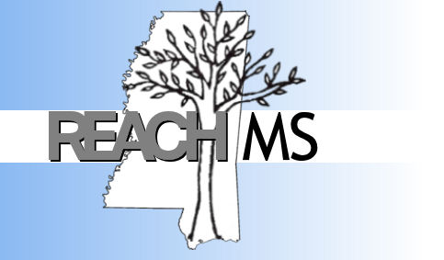
REACH MS
Mississippi’s State Personnel Development Grant
University of Southern Mississippi Phone: 601.266.4693
118 College Drive #5057 Fax: 601-266-4691
Hattiesburg, MS 39406 Email: REACHMS@usm.edu

Realizing Excellence for ALL Children in Mississippi

Tier 2 Systems and Interventions for Behavioral Support
Training Readiness Checklist

School: ________________________________________________ District: ________________________________________________ Date: _________

Person Submitting Checklist: ________________________________________________ Email: ________________________________________________
Directions: Each participating school is required to complete several items prior to receiving Tier 2 Systems and Interventions for Behavioral Support. Completion of this checklist (within the time-frame) ensures more positive outcomes and allows your school to participate in upcoming Tier 2 trainings sponsored by REACH MS.
Requirement | Completed? |  | Action
1. Tier 1 system in place with documentation readily available. (i.e., 80% on Benchmarks of Quality or School Evaluation Tool) | - Yes | - No
2. Tier 2 Team members have been identified. | - Yes | - No
3. Universal screening procedures are established to identify students in need of Tier 2 interventions and supports. | - Yes | - No
4. Processes are in place to communicate with faculty, staff and family members regarding students in need of Tier 2 supports. | - Yes | - No
5. 5. Professional development is or will be provided on practices and  systems required for Tier 2. | - Yes | - No | Marking yes, indicates that the principal has agreed to this commitment.
6. Tier 2 Team commits to meeting at least monthly to analyze and problem solve individual student data and to develop appropriate Tier 2 behavioral interventions. | - Yes | - No | Location: ____________________________________  Date/Day: __________________________________  Time: _______________________________________
7. Principal or assistant principal who is responsible for making decisions is an active participant on the Tier 2 team and agrees to attend all Tier 2 trainings. | - Yes | - No | List of Participating Administrators
8. A school improvement plan exists that includes discipline (i.e., behavior, school safety, school climate) as one of the top school goals. | - Yes | - No | Marking yes, indicates that the principal has agreed to this commitment.
9. REACH MS has permission to utilize product samples for  future trainings, technical assistance activities, professional  conference presentations, or submission to scholarly publications  and may request occasional site visits. | - Yes | - No | Marking yes, indicates that the principal has agreed to this commitment.
10. A District Coach has been identified to attend Tier 2 training  with your team and provide additional support to your Tier 2 Team  throughout the year. | - Yes | - No | Marking yes, indicates that the principal has agreed to this commitment.

