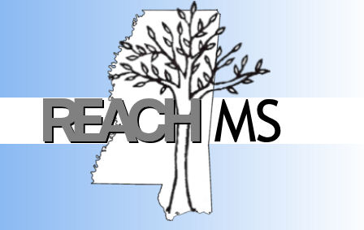
REACH MS
Mississippi’s State Personnel Development Grant
University of Southern Mississippi Phone: 601-266-4693
118 College Drive #5057 Fax: 601-266-4691
Hattiesburg, MS 39406 Email: REACHMS@usm.edu

Realizing Excellence for ALL Children in Mississippi

January 16, 2013

REACH MS, Mississippi's federally funded program designed to address Positive Behavior Interventions and Supports (PBIS), is looking for SWPBIS (School-Wide PBIS) model demonstration sites across our state. Currently we have identified twenty six model schools but have fourteen slots available to schools that are implementing SWPBIS with fidelity.

The process for being recognized as a model site is as follows:
- The school performs a self-assessment using the PBIS Benchmarks of Quality (BOQ) to determine if the school is implementing with 80% fidelity
- The school completes the online SWPBIS Model Site Application. The application is on our website www.usm.edu\reachms under ‘Model Sites’.
- Email REACH MS (reachms@usm.edu) to notify us that the application has been completed.
- REACH MS staff will review your application and contact you regarding any questions and/or to schedule your Model Site evaluation.
- REACH MS visits the school to administer the SET (School Evaluation Tool) and the school receives a score of 80% or greater.

Once recognized as a model site each school receives:
- A $2500 incentive to be used to support their PBIS process
- Recognition on a local, state and national level as a Mississippi Model PBIS Demonstration Site

Requirements of being a model site are:
- Sharing information from your PBIS process with others by allowing PBIS teams from other schools to tour your demonstration site
- Submitting your PBIS data (ODRs, suspensions, expulsions) to REACH MS quarterly and a BOQ annually
- SWPBIS Team Leader attending REACH MS Team Leader Trainings throughout the year

If you are interested in this opportunity, please let us know. Also, if you know of others interested, we would very much appreciate you sharing this information.

We are excited about building our REACH MS PBIS Model Site Network and look forward to hearing from you.

The REACH MS Team

