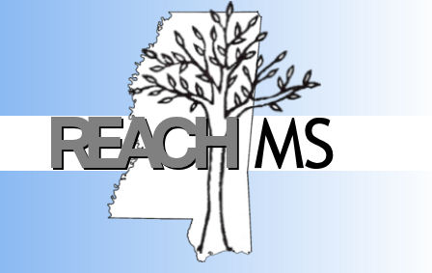
REACH MS
Mississippi’s State Personnel Development Grant
University of Southern Mississippi Phone: 601.266.4693
118 College Drive #5057 Fax: 601-266-4691
Hattiesburg, MS 39406 Email: REACHMS@usm.edu

Realizing Excellence for ALL Children in Mississippi
www.usm.edu/reachms

Positive Behavioral Interventions and Supports:
A Response to Intervention Model

As Mississippi's federally funded program designed to address Positive Behavioral Interventions and Supports (PBIS), REACH MS recognizes the value of providing professional development opportunities to all school staff members using research-based practices. In an effort to support this and in consideration of budget and travel constraints all districts are facing at this time REACH MS is offering a FREE regional PBIS training at the Tier 1 and Tier levels. We would like to invite you to send the appropriate personnel (teams) from your district to attend. All participants will leave with the necessary materials and information to return to their schools and begin implementing these systems change processes.

School-wide Positive Behavioral Interventions and Supports (SWPBIS)
New Team Training

This two day training provides the participant the opportunity to learn all of the necessary Critical Elements of SWPBIS in order to implement systems change regarding Tier 1 of the Response to Intervention initiative. It is highly recommended that a school-based team attend the training. The team should include, but is not limited to, school administrators, general education teachers, special education teachers, behavioral specialists, and family members.

Beyond SWPBIS Data Based Decisions and Tier 2

This two day training provides the participant the opportunity to learn how to collect and analyze data in order to make data-based decisions on a school-wide (Tier 1) and secondary (Tier 2 level). Participants will learn what school-based data to collect in order to implement evidence-based interventions and progress monitor the intervention to determine its effectiveness. The participant will also learn the Essential Elements of Mississippi’s Response to Intervention initiative regarding Tier 2 interventions, data collection and progress monitoring. It is highly recommended that a school-based team attend the training. The team should include, but is not limited to, school administrators, general education teachers, special education teachers, behavioral specialists, and family members.

